Images
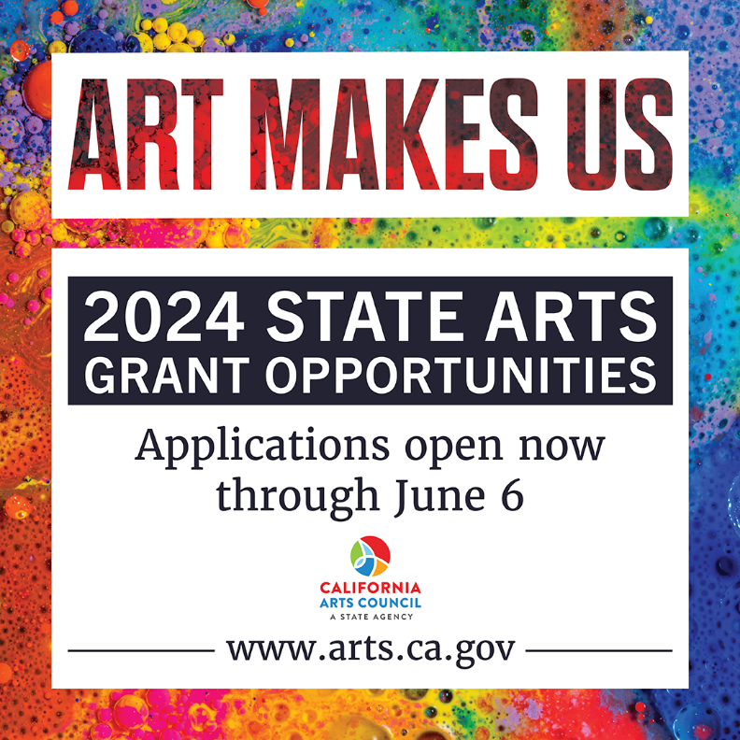
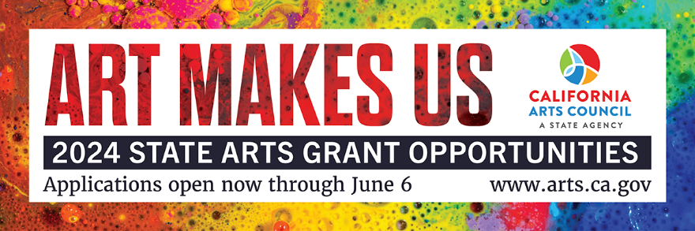

Social Media
Suggested Text:
California’s arts grant season is in full swing! @CalArtsCouncil has 8 grant opportunities open now - learn more and apply for your organization's state arts funding by June 6 at www.arts.ca.gov.

Hashtags:
#ArtsCA #ArtMakesUs

Tag in image:
@calartscouncil
other partner organizations that you are collaborating with

Newsletter
Suggested Text:
The California Arts Council’s state arts grant season is in full swing! Grant program offerings for 2024 were selected and developed with several of the agency’s stated values in mind, among them accessibility, autonomy with accountability, equity, and sustainability.
New and varying policies have been implemented across each of the eight programs in an effort to achieve maximum benefit and broadest impact across the state. These include caps on organizational revenue and restrictions on applying for multiple project-based grants under the Arts & Youth programs umbrella.
Full details can be found on the webpages for each individual grant program. Technical and training resources for applicants are also available.

Other Included Attachments
- Grant Season General Flyer

